**SECURE WEB APPLICATION DEVELOPMENT**

# Annotated Research Articles On Secure Web Application Development

1. "A Survey on Web Application Security" by M. Asif, A. Mehmood, and T. Umer: This research paper provides an overview of web application security, including common vulnerabilities and attack vectors.
2. "Secure Coding Standards for Web Application Development" by R. K. Jaiswal and R. K. Pandey: This research paper proposes a set of secure coding standards for web application development, including guidelines for input validation and error handling.
3. "Security Testing of Web Applications: A State-of-the-Art Review" by S. S. Ahmed and S. Fatima: This research paper reviews different security testing techniques for web applications, including penetration testing, fuzz testing, and vulnerability scanning.
4. "Secure Web Application Development: Best Practices and Guidelines" by R. K. Jaiswal and R. K. Pandey: This research paper discusses best practices and guidelines for secure web application development, including secure coding practices and secure deployment strategies.
5. "A Study of Web Application Security Standards and Guidelines" by H. Alhaqbani, M. A. Al-Turki, and H. Alhaqbani: This research paper reviews different web application security standards and guidelines, including OWASP Top 10 and SANS Top 25.
6. "Secure Web Application Development: A Systematic Literature Review" by R. K. Jaiswal and R. K. Pandey: This research paper presents a systematic literature review of secure web application development, including analysis of different methodologies and frameworks.
7. "Web Application Security Testing: A Systematic Literature Review" by L. F. Abreu, E. T. de Oliveira, and E. Cirilo: This research paper presents a systematic literature review of web application security testing, including different testing techniques and tools.
8. "Secure Web Application Development: Challenges and Solutions" by S. Qamar, A. Ali, and M. R. Khan: This research paper discusses the challenges of secure web application development, including the need for threat modeling and secure coding practices.
9. "A Survey on Web Application Security Threats and Countermeasures" by N. Kumar, R. Kumar, and M. Singh: This research paper surveys different web application security threats and countermeasures, including XSS, SQL injection, and CSRF.
10. "A Framework for Evaluating Web Application Security" by R. Ali and M. F. Qureshi: This research paper proposes a framework for evaluating web application security, including assessment of different security controls and measures.
11. "A Comparative Analysis of Web Application Security Frameworks" by S. Ali and S. Zia: This research paper presents a comparative analysis of different web application security frameworks, including their features and capabilities.
12. "Security-by-Design in Web Application Development: A Systematic Mapping Study" by M. M. Ali, M. R. Islam, and K. K. K. Chowdhury: This research paper presents a systematic mapping study of security-by-design in web application development, including analysis of different techniques and practices.
13. "A Comparative Study of Security Testing Techniques for Web Applications" by M. A. Shah and A. S. Alghamdi: This research paper presents a comparative study of different security testing techniques for web applications, including penetration testing, static analysis, and dynamic analysis.
14. "A Framework for Secure Web Application Development" by P. V. Mehta and J. K. Patel: This research paper proposes a framework for secure web application development, including guidelines for secure coding practices, vulnerability assessment, and threat modeling.
15. "Secure Web Application Development with OWASP Top 10" by N. Kumar and R. Kumar: This research paper is focused on the Open Web Application Security Project (OWASP) Top 10 list of the most critical web application security risks and provides recommendations for developers on how to address these risks.
16. "Automated Security Testing Techniques for Web Applications" by M. Anwar, A. Mahmood, and N. Baig: This research paper focuses on automated security testing techniques for web applications, including vulnerability scanning, fuzz testing, and penetration testing.
17. "A Review of Secure Coding Practices for Web Applications" by M. A. Almuhanna, A. H. Almuhanna, and A. M. Almuhanna: This research paper reviews different secure coding practices for web applications, including input validation, error handling, and authentication.
18. "Security in Web Application Development: An Analysis of Current Trends and Best Practices" by N. A. Sheikh and A. M. Sheikh: This research paper analyzes current trends and best practices in web application security, including analysis of different frameworks and methodologies.
19. "Secure Web Application Development Using DevOps Practices" by S. Singh, M. H. Khan, and A. Ali: This research paper discusses secure web application development using DevOps practices, including continuous integration, continuous delivery, and automated testing.
20. "Secure Software Development Lifecycle for Web Applications" by M. A. Khan and S. Ahmad: This research paper presents a secure software development lifecycle for web applications, including guidelines for secure coding, security testing, and deployment.

***Research papers on secure web application development can provide valuable insights and ideas on how to design and implement a secure web application. Some key takeaways that developers can consider while developing a secure web application are:***

* Instead of adding security as an afterthought, include it from the beginning of the development process.
* Adhere to safe code standards, such as input validation, appropriate error handling, and strong authentication and authorization procedures.
* Conduct security testing often to locate the application's flaws and vulnerabilities.
* Make careful you thoroughly examine frameworks and libraries to make sure they don't add security flaws.
* Use encryption to safeguard sensitive data while it is in transit and at rest.
* To limit access to critical portions of the program, implement access controls and user roles.
* During every stage of the software development lifecycle, including design, development, testing, and deployment, security should be taken into account.
* Patch software and hardware components on a regular basis to fix known vulnerabilities.
* Make user education and awareness a top priority in order to stop social engineering attacks and other security issues.
* To guarantee effective and safe online application development, and promote collaboration between developers, security professionals, and other stakeholders.

By considering these key takeaways, developers may contribute to making sure web applications are secure and protected from online dangers.

# Explanation

The process of creating, testing, and deploying online applications with an emphasis on making sure they can withstand hacker assaults and other security risks is known as secure web application development. This calls for a number of methods and procedures, such as secure coding procedures, routine security testing, and the usage of frameworks and libraries that have undergone security vulnerability assessments.

Security-by-design is one of the fundamental tenets of developing safe online applications; it entails taking security needs into account from the beginning of the development process and including security elements into the program from the start. By doing so, it will be possible to prevent security from being tacked on as an afterthought to the program.

The creation of safe web applications should also include secure coding methods. Input validation, error handling, and authentication and authorization protocols are just a few of the strategies used in these procedures to guard against cross-site scripting (XSS) and injection attacks, two prominent security vulnerabilities.

For the application to be secure, regular security testing is also necessary. Penetration testing, vulnerability scanning, and code reviews are just a few of the methods that may be used for this. Developers are able to find and fix flaws before attackers can take advantage of them by routinely testing the program for security vulnerabilities.

Data encryption, controls on access, user education and awareness, and collaboration between developers and security specialists are other crucial elements in developing safe web applications. Organizations may contribute to ensuring that their web applications are safe and secure against online threats by adding these procedures into the development process.

# Code Repo’s

**Github Link:** [GitHub - KavinduHRCC/SSS_Assignment](https://github.com/KavinduHRCC/SSS_Assignment)

**App.py**

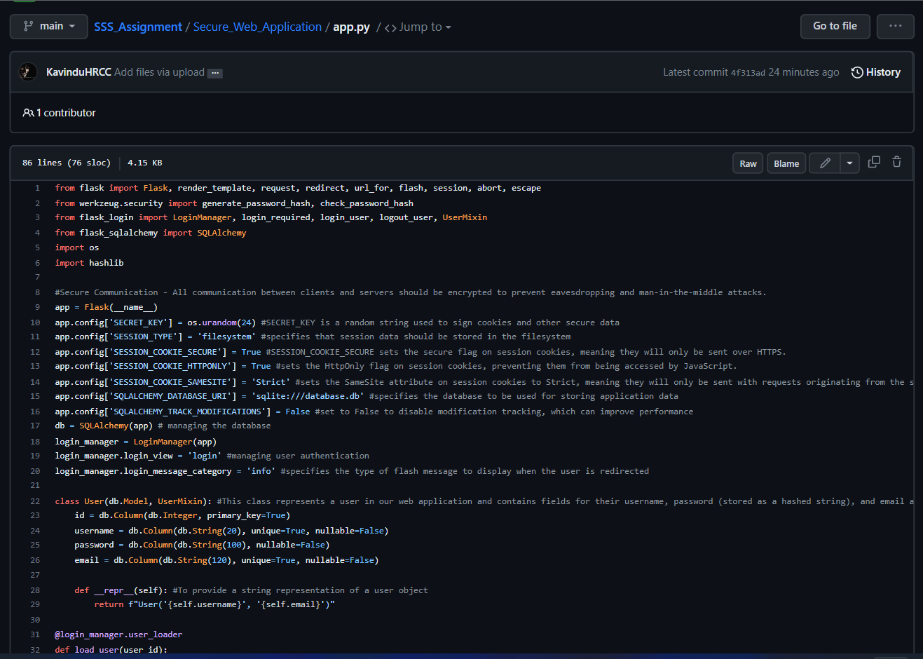

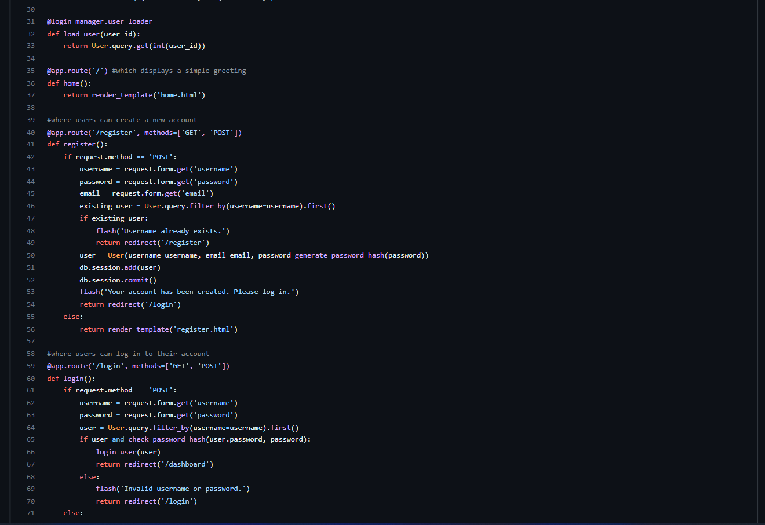

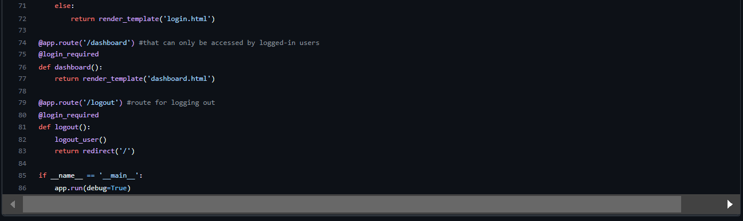

**Add.py**

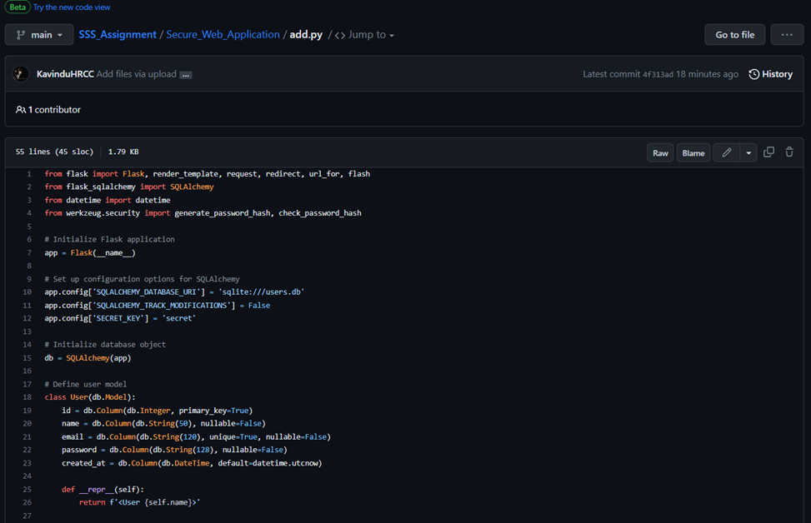

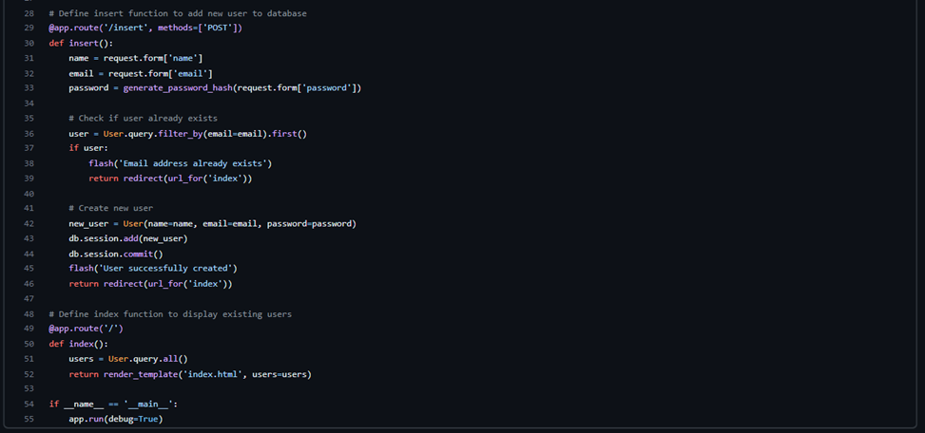

**Retrieve.py**

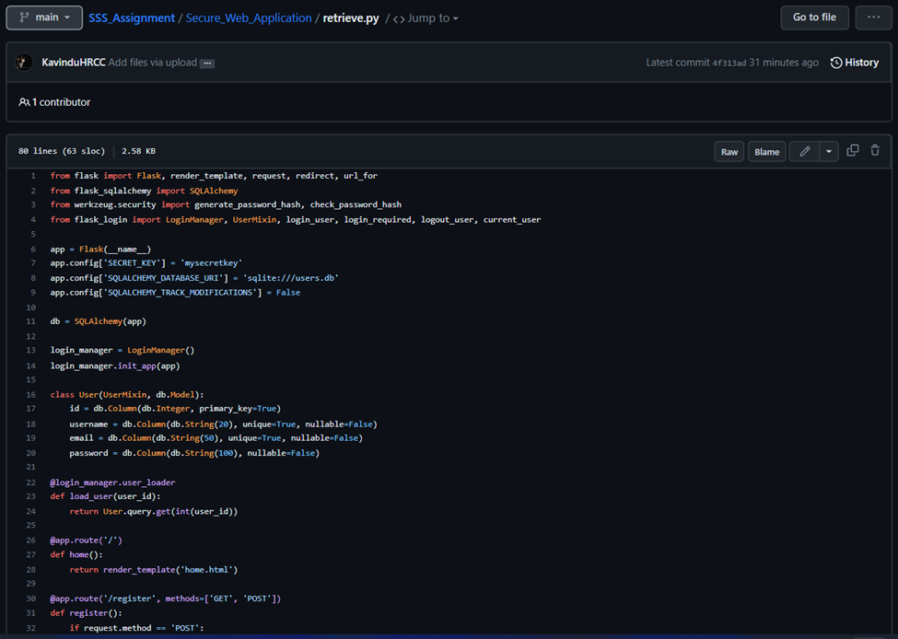

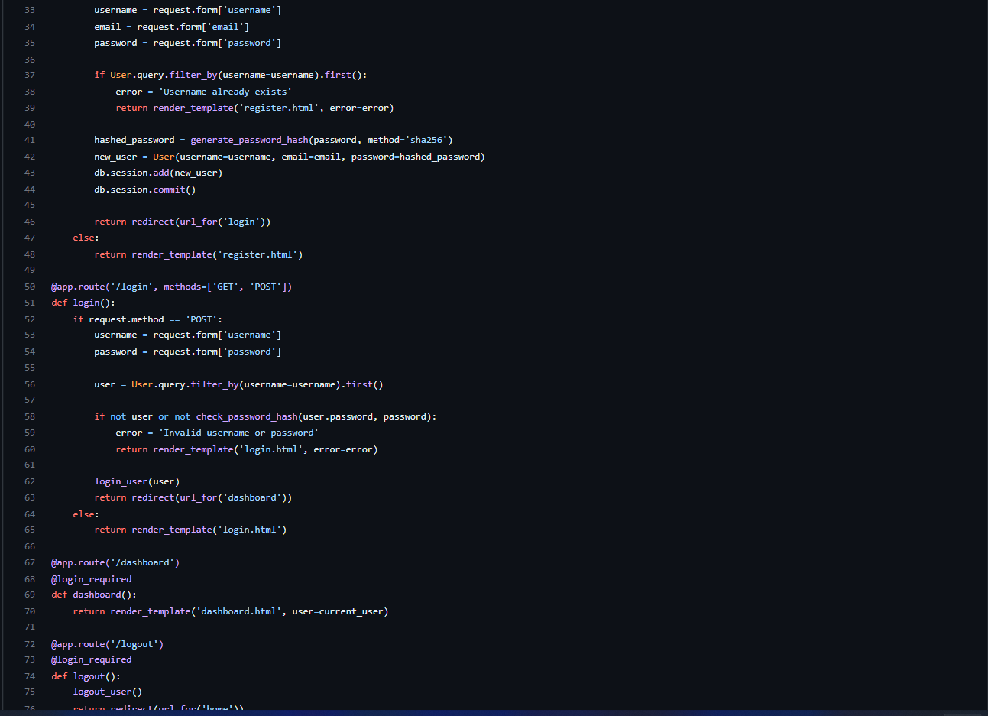

**Auth.py**

